**Name:** Rameen **Roll No:** 2023-EE-03

EE-322L Analog and Digital Communication Marks Obtained: ________

**Lab Report**

**Experiment No. 1**

**Exponential Fourier Series**

**Note:**

* **Don’t forget to include the rubrics table (available at the end in this document), otherwise reports will not be graded.**
* **Copy-pasted and plagiarized reports will get zero marks**

**Ensure proper comments are there in the source code of each task**

**Note:**

* **Don’t forget to include the rubrics tables (available at the end in this document), otherwise reports will not be graded.**
* **Copy-pasted and plagiarized reports will get zero marks**
* **Ensure proper comments are there in the source code of each task**

1. **Objective**

The objective of this experiment is to compute the exponential Fourier series coefficients of a given periodic signal, plot their magnitude and phase, and reconstruct the approximate time-domain signal using a finite number of coefficients.

1. **Technical Background**

Fourier series is a method to represent any periodic signal as a sum of sinusoidal or exponential functions. The exponential form is commonly used in engineering because it simplifies computation and leads naturally to the Fourier Transform. In this form, a periodic signal is written as:

**D(t) = $\sum_{n= -∞}^{n=∞}{D_{n} e^{jnw_{o}t}}$**

where $D_{n}$ are complex coefficients that describe the amplitude and phase of each harmonic component. Using a finite number of these coefficients, the original signal can be approximately reconstructed and analyzed in the frequency domain.

1. **Task-1**
   1. ***Description of Task-1***

Evaluate the Fourier series coefficients using the formula:

**Dₙ = (1/4) * exp(-j n π / 4) * sinc(n/4)**

Plot the **magnitude** |Dₙ| (in volts) and **phase** ∠Dₙ (in degrees) of the first twenty-one **coefficients n = [-10, … , 10]** versus **frequency** (in rad/sec). Also, determine the time period of the corresponding time domain signal D(t).­­

* 1. ***Source Code for Task-1***

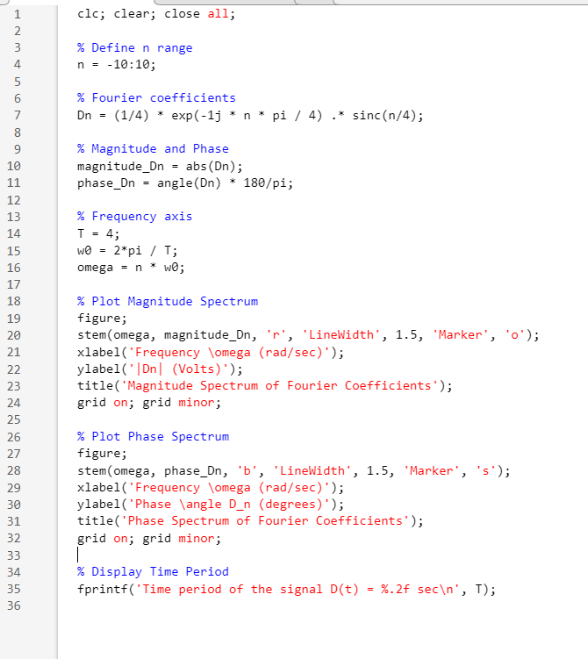

* 1. ***Results and Discussions for Task-1***

# *Magnitude spectrum:*

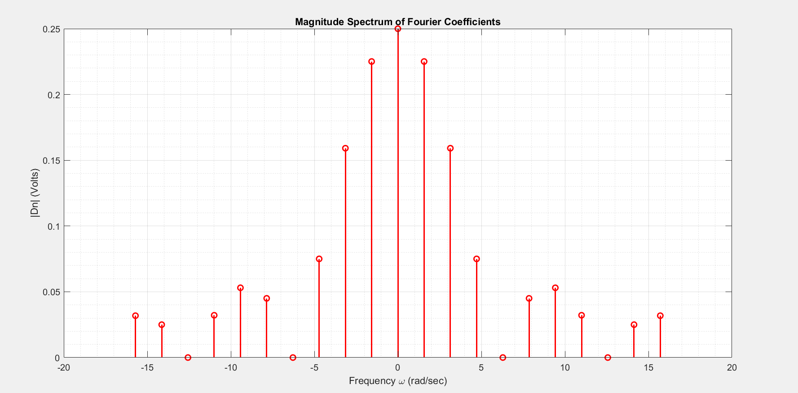

1. *Phase spectrum:*

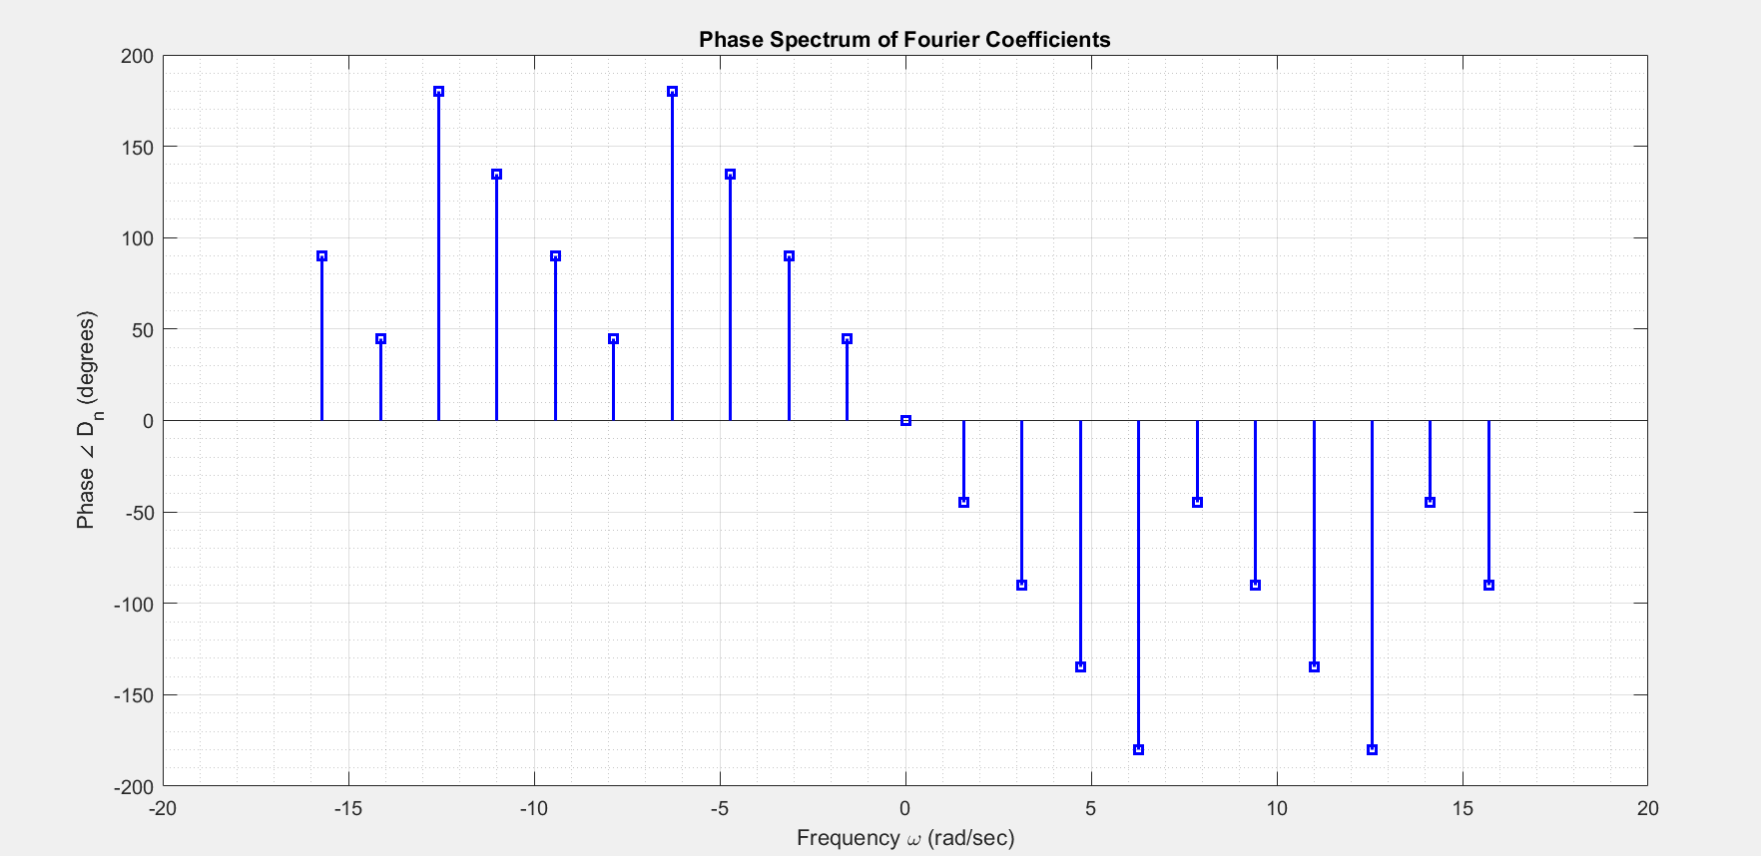

1. Time period of the signal D(t) = ***4.00 sec***

Magnitude of Dn is maximum at 0 rad/s, and decreases as the frequency goes up, both for positive and negative frequencies. The phase of Dn varies from -180 to 180 degrees.

1. **Task-2**
   1. ***Description of Task-2***

From the above first twenty-one terms of the exponential Fourier series of Dₙ, plot an approximation to its corresponding time domain signal D(t) given by:

**D(t) ≈ $\sum_{ n= -10}^{n=10}{D_{n} e^{jnw_{o}t}}$**   
   
Use t = [0:0.01:4] seconds or any other appropriate period.

* 1. **Source Code for Task-2**

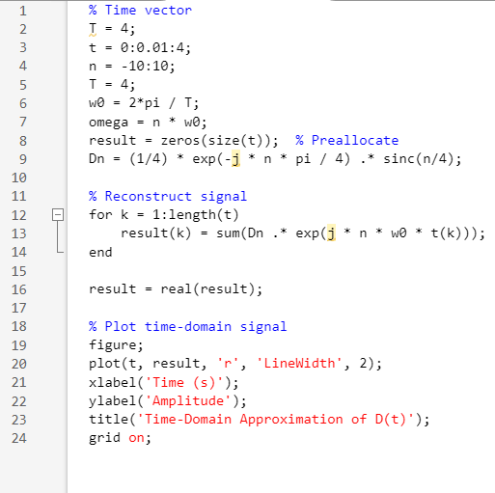

* 1. **Results and Discussions for Task-2**

## Plot of signal in time domain:

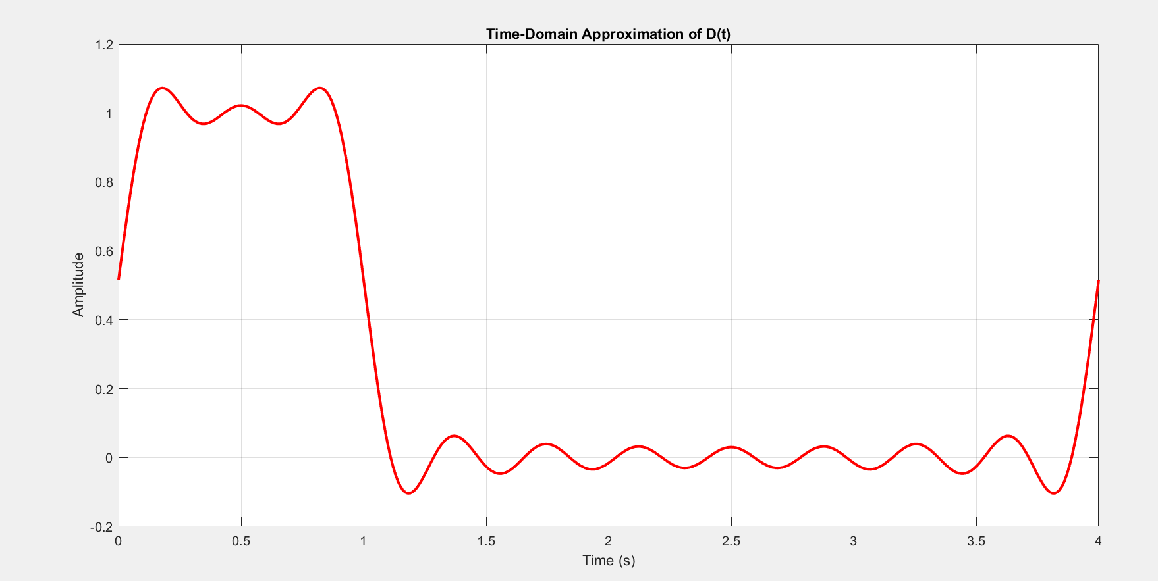

The approximate signal is close to a periodic square pulse, which has a period of 4 sec.

1. **Conclusion**

In this experiment, the exponential Fourier coefficients were calculated and analyzed. The plots confirmed the theoretical behavior of magnitude and phase. The truncated exponential Fourier series successfully reconstructed an approximate version of the time-domain signal, demonstrating the power and practicality of the Fourier series representation.

**Rubrics for Experiment No.**

|  |  |  |  |  |
| --- | --- | --- | --- | --- |
| **Performance** | **Exceeds expectation (2)** | **Meets expectation (1)** | **Does not meet expectation (0.5)** | **Marks** |
| **R1:** Knowledge of required functions for code design.  **Marks: 0-2** | Has required knowledge for code | Has partial knowledge for code | Has no knowledge for code |  |
| **R2:** Simulation of experiment **Marks: 0-2** | Simulates all the tasks correctly by himself | Needs guidance to simulate the tasks correctly | Incapable to simulate the tasks correctly by himself even with  guidance |  |
| **R3:** Demonstrate proper results with justification  **Marks: 0-2** | Correct results are provided with required  justification | Results are provided with minor errors and/or with little  justification | Results are provided with major errors and/or with no  justification |  |

**Rubrics for Lab Manual No.**

|  |  |  |  |  |
| --- | --- | --- | --- | --- |
| **Performance** | **Exceeds expectation (0.5)/(0.25)** | **Meets expectation (-)/(-)** | **Does not meet expectation**  **(0)/(0)** | **Marks** |
| **R1:** Timely submission  **Marks: 0-0.5** | The submission is on  time | --- | Late submission |  |
| **R2:** Report completeness  **Marks: 0-0.25** | All relevant calculations,  specifications, code, graphs, and results are provided with proper explanation. | All the relevant calculations,  specifications, code, graphs and results  are provided but with little  explanation and justification. | Most of the relevant graphs, results, calculations,  specifications, and code are missing, as well as  their proper explanation and justification is also missing. |  |
| **R3:** Error-free writeup  **Marks: 0-0.25** | The submitted assignment is without any  plagiarism and formatting errors. | Some parts of the submitted  assignment contain formatting errors and plagiarized material. | The submitted  assignment is mostly plagiarized and contain formatting errors. |  |